Calcitonin Gene-Related Peptide (GCRP) as a Target for Migraine Therapy: A Promising Treatment on the Horizon

Elizabeth Leroux, MD, FRCPC
University of Calgary, Calgary, Canada

What is CGRP?
CGRP is a potent vasodilatory peptide. It is also involved in nociception and inflammation. CGRP is found in the trigeminal system but also in other areas of the brain such as the cerebellum. It plays a role in other systems such as vestibular function, sweating regulation and neuroplasticity.

What is the role of CGRP in the pathophysiology of migraine?
The pain experienced during a migraine attack is generated by the stimulation of sensory nerve fibers adjacent to intra-cranial arteries and meninges. The cascade ending in peptide release is now thought to be initiated in the hypothalamus in response to an accumulation of triggers and is mediated by the trigeminal nucleus. There is strong research evidence that CGRP is one of the mediators released during the neurogenic inflammatory cascade of the migraine attack and that blocking CGRP can treat migraine pain. IV CGRP administration triggers a migraine headache in individuals with migraine, and elevated venous levels of CGRP are present in patients with migraine both during and between attacks.

Persistent release of CGRP may play a role in the chronification of migraine, lowering attack threshold and causing persistent allodynia and sensory hypersensitivity (photophobia and phonophobia). CGRP has also been linked to the pathophysiology of medication-overuse headache. There is a robust rationale that blocking CGRP could prevent migraines.

Until now, headache preventives were drugs created for other diseases (e.g., epilepsy, depression, hypertension) and found to have an effect on migraine. Treatments targeting CGRP were engineered based on our current scientific understanding of migraine pathophysiology, and they will be the first drugs to be designed specifically for the prevention of migraine and other headache types.

CGRP is being studied for the acute and preventive treatment of migraine and cluster headache. Two approaches are employed: (1) monoclonal antibodies directed against the CGRP ligand or receptor and (2) small molecules targeting CGRP.

MONOCLONAL ANTIBODIES DIRECTED AGAINST CGRP

What is the pharmacology of antibodies?
Antibodies are produced by the immune system to control infectious or tumoral processes. After binding to their specific proteic target, they block its function. Antibodies are now biologically engineered as treatments targeting proteins involved in pathological networks. There are different ways to synthetize antibodies, and there are different subtypes based their human or murine (mouse) composition.

Antibodies are large molecules that cannot be absorbed orally, and are therefore administered by injection (subcutaneous or intravenous). They are metabolized by the lymphatic system, by proteolysis, and may also be catabolized and recycled. Their half-life is usually quite long. For example, the antibodies designed for migraine have half-lives between 21 and 45 days, making dosing at monthly (or even less frequent) intervals possible.

What are CGRP MABs and are there different subtypes?
Four MABs for the prevention of headache are being tested: galcanezumab, erenumab, fremanezumab and eptinezumab; some are also in clinical trials for the prevention of cluster headache. Presently, three antibodies are designed to block CGRP itself, and one blocks the CGRP receptor. CGRP MABs do not block other proteins than CGRP or its receptor, so the immunogenic potential is low. Currently, all four CGRP MABs have demonstrated safety and efficacy in Phase 2 and 2b clinical trials for migraine in humans. The Phase 3 trials are underway.

What is the clinical benefit of CGRP MABs regarding migraine frequency?
In the studies available so far, the results have been promising, both for episodic and chronic migraine. Overall, one-third of patients receiving the antibody observed a 75% decrease in frequency of their migraines. These patients are sometimes called “super-responders”. A third observed a 50 to 70% benefit, which is the usual success threshold for migraine treatment efficacy. One third did not respond significantly.

The speed of onset of CGPR MABs is quite fast, with significant differences between active treatment and placebo observed as early as the first week after the initial dose. The benefit is sustained over time.

CGRP MABs may not have 100% efficacy because other peptides play a role in the migraine inflammatory process. For certain patients, CGRP may not be the major factor.

What are the side effects observed in the clinical trials?
Many drugs prescribed for migraine have significant side effects and are a major reason for discontinuation and decreased quality of life. In the published studies, CGRP MABs seem to be very well tolerated. Side effects such as fatigue and nausea are reported in less than 5% of patients. Weight gain and cognitive difficulties have not been reported. One explanation for this good tolerability is the specificity of the CGRP MABs. Because CGRP MABs are administered by injection, local reaction to the injections can be seen in up to 10% of patients but are usually mild. No severe side effect caused by the drug has been reported in the literature so far.

What is the expected safety of these compounds?
CGRP plays an important role for the vasodilation of arteries, especially in sub-ischemic situations. Blocking CGRP may impact the protective vasolidatory response during a stroke or myocardial infarction. It may also modulate the control of arterial pressure. No severe vascular adverse events have been reported in the studies so far, either in animals or humans. This is reassuring but caution is still advised and long-term studies are essential. Certain patients may be more at risk than others.

CGRP antibodies are otherwise considered to be safe in regard of hepatic, renal and hematologic functions. They do not target the immune system and should not raise the risk of infection or cancer. The blood-brain-barrier does not allow the entry of antibodies in the central nervous system, therefore the cerebral functions should not be affected. This may also explain the good tolerability observed in studies.

When will CGRP MABs arrive on the US market?
Phase III studies are underway. FDA approval is anticipated in 2018.

SMALL MOLECULES TARGETING CGRP

How do the small molecules differ from monoclonal antibodies?
Because of their size, the small molecules can be taken orally. They are metabolized by the liver and eliminated through the kidneys. They may enter cells and cross the blood-brain barrier. Their half-life is short, ranging from minutes to hours. As acute treatments, their lack of vasoconstrictive properties offers a potential advantage for patients in whom triptans are contraindicated.

What is the status of small molecule CGRP antagonists?
Telcagepant was tested for both the acute and preventive treatment of migraine over 15 years ago. Although the efficacy was equivalent to triptans for acute treatment, the trial for prevention was stopped in 2009 because some participants developed markedly increased transaminase levels and further development was abandoned. The small molecules have been re-engineered to avoid hepatic toxicity. Clinical trials of ubrogepant and atogepant are underway (Phase II) for migraine treatment.

References:

- Bigal ME, Walter S, Rapoport AM. Therapeutic antibodies against CGRP or its receptor. British journal of clinical pharmacology. 2015;79(6):886-95.
- Edvinsson L. CGRP receptor antagonists and antibodies against CGRP and its receptor in migraine treatment. British journal of clinical pharmacology. 2015;80(2):193-9.
- MaassenVanDenBrink A, Meijer J, Villalon CM, Ferrari MD. Wiping Out CGRP: Potential Cardiovascular Risks. Trends in pharmacological sciences. 2016.
- Wrobel Goldberg S, Silberstein SD. Targeting CGRP: A New Era for Migraine Treatment. CNS drugs. 2015;29(6):443-52.
- Voss T, Lipton RB, Dodick DW, Dupre N, Ge JY, Bachman R, et al. A phase IIb randomized, double-blind, placebo-controlled trial of ubrogepant for the acute treatment of migraine. Cephalalgia. 2016 ;36 :887-98.

Tables: Summary of efficacy of CGRP MABs in Phase 2 clinical studies

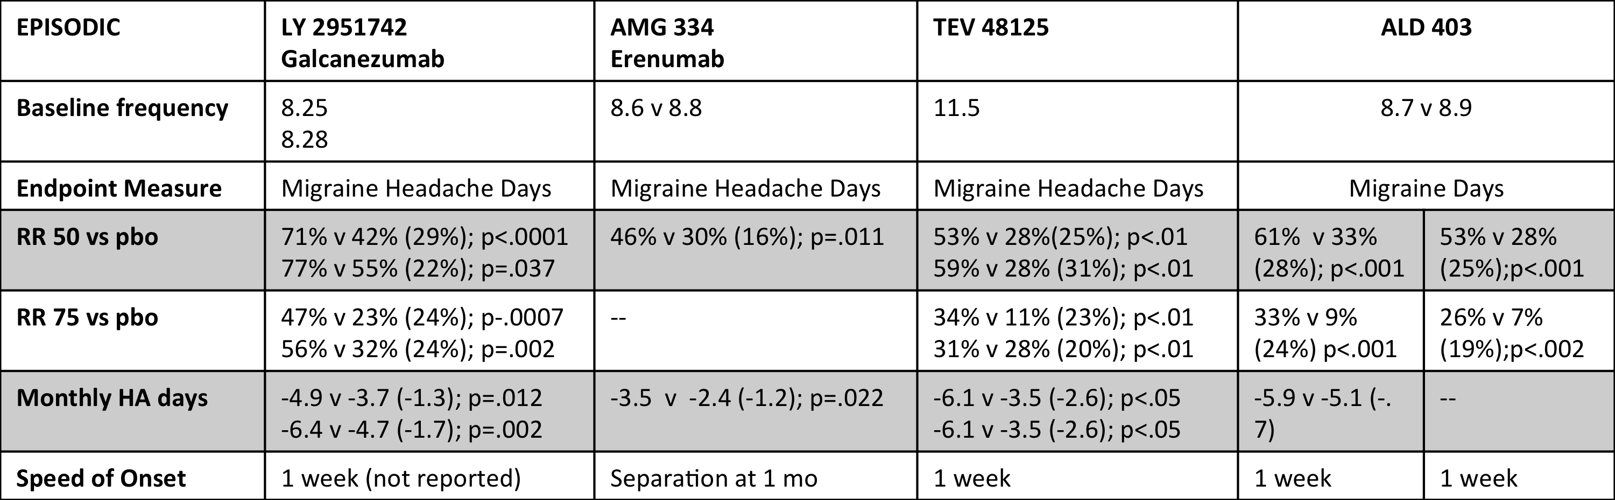

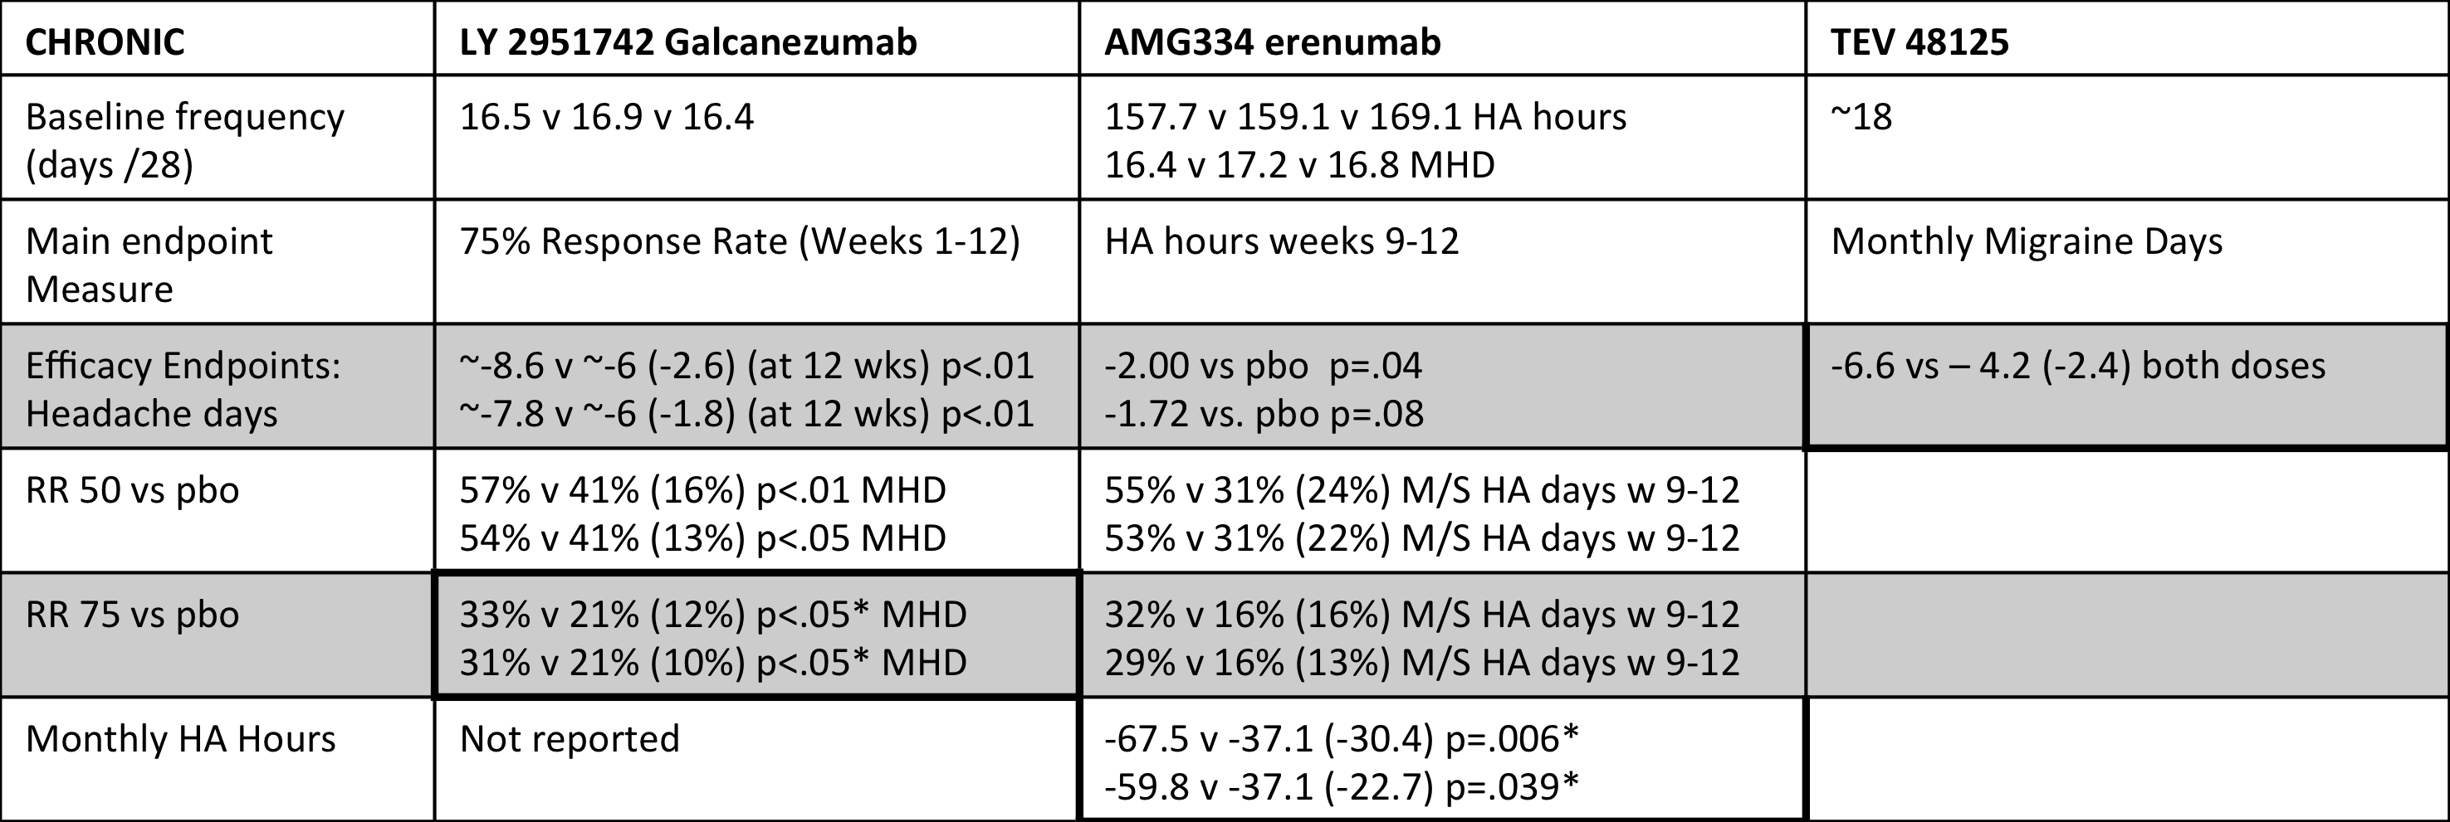
Possible images:

Antibody:

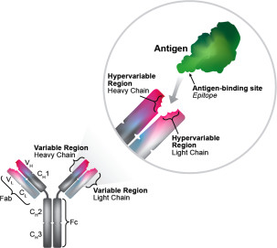

CGRP in migraine pathophysiology

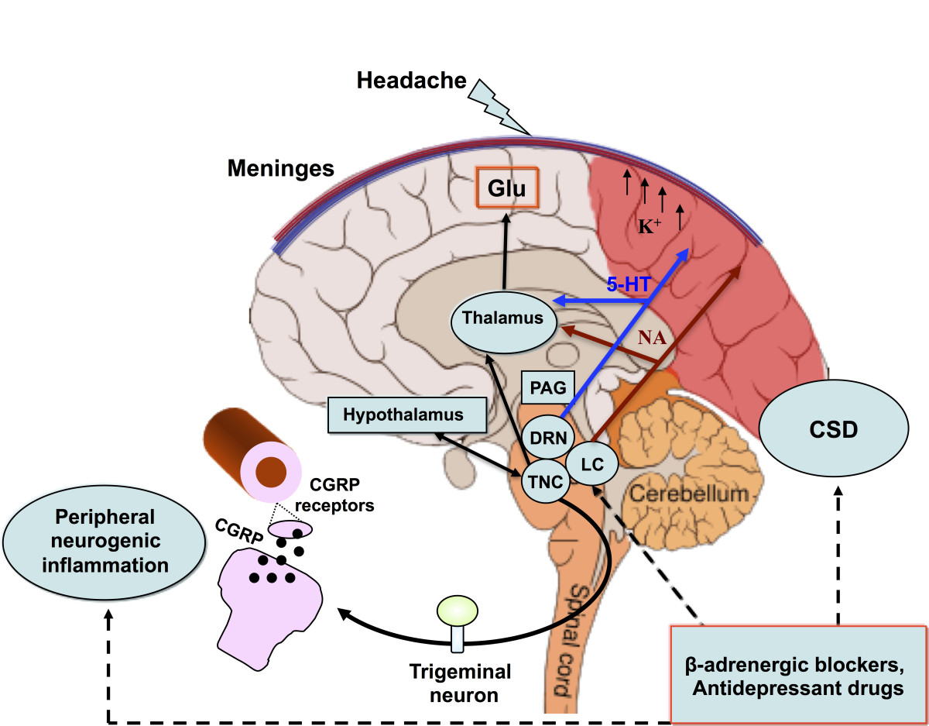

CGRP roles in the body
